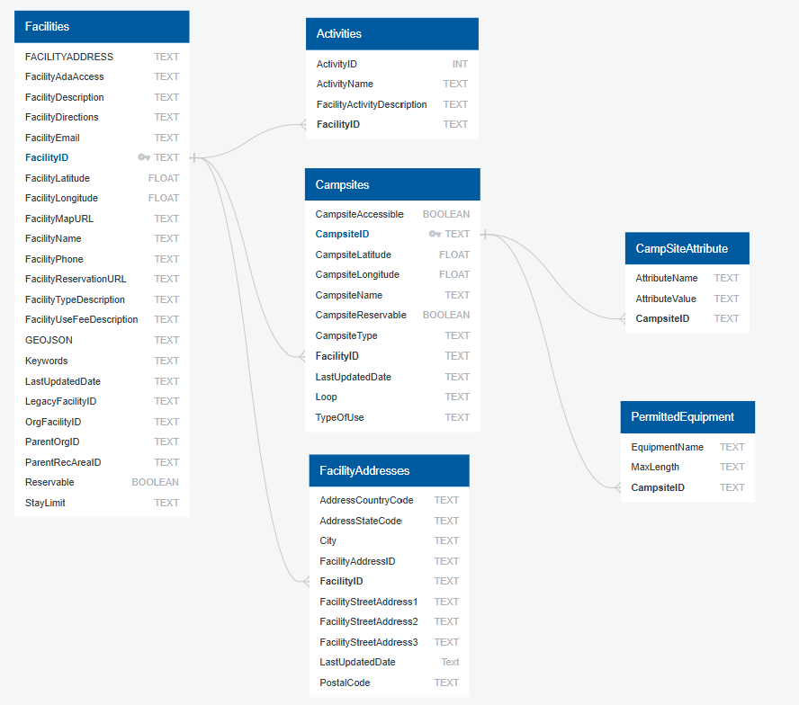

Facilities DataFrame: RangeIndex: 848

Activities DataFrame: RangeIndex: 5105

Campsites DataFrame: RangeIndex: 9131

Campsite Attributes DataFrame: RangeIndex: 173616

Permitted Equipment DataFrame: RangeIndex: 29394

